Task 1
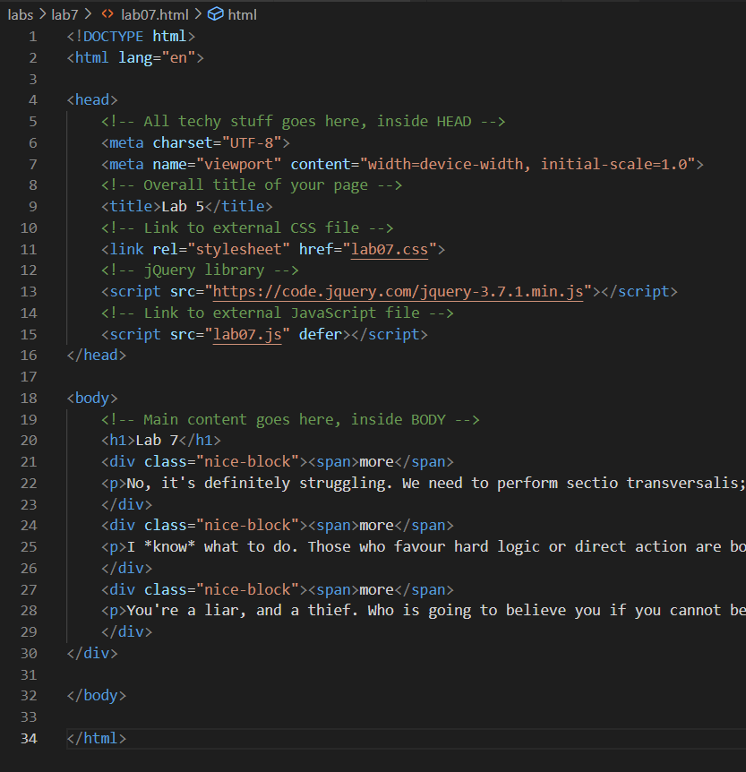
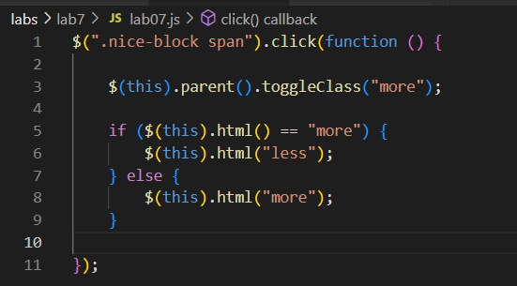
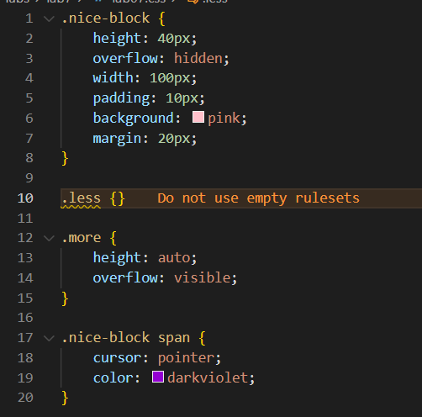
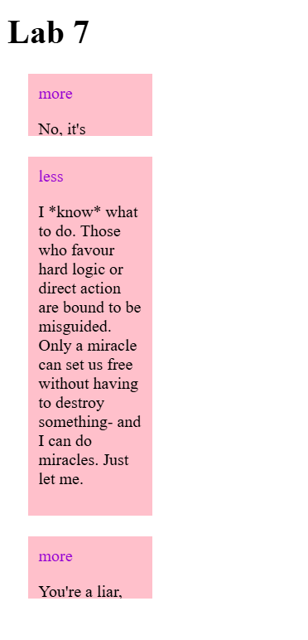
JS selects the source of the click with $(this) and adjusts the css tag to be expanded or retracted. The word is changed simply by adjusting the html contents of the span at the top of the block, an elementary if-then-else statement. If it’s ‘more,’ change to ‘less,’ otherwise it’s ‘more.’

Task 2
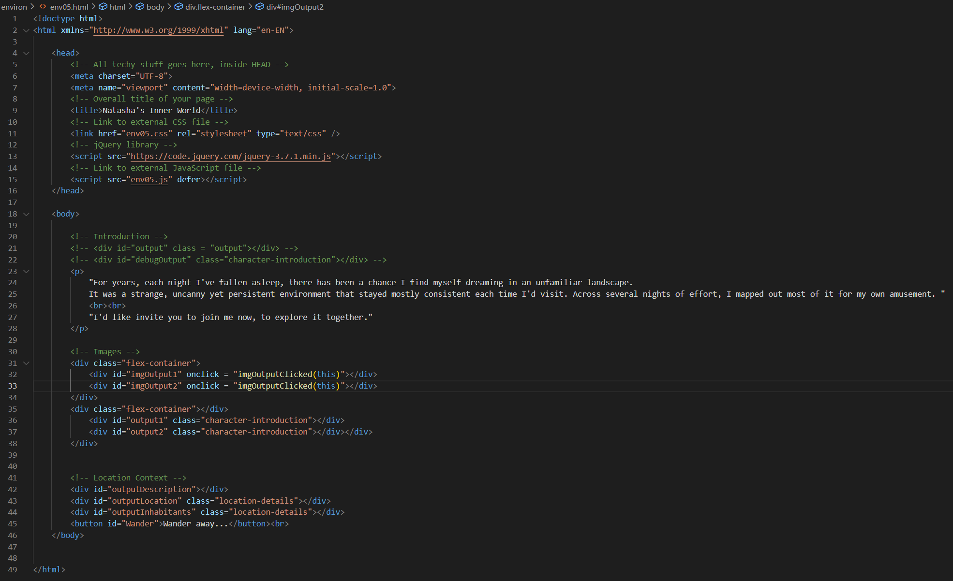
Only adding the js code changes here, since the document is way too large for a screenshot or two.
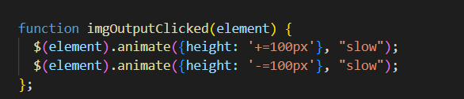
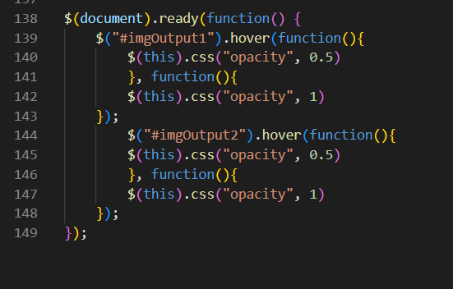
CSS is unmodified.
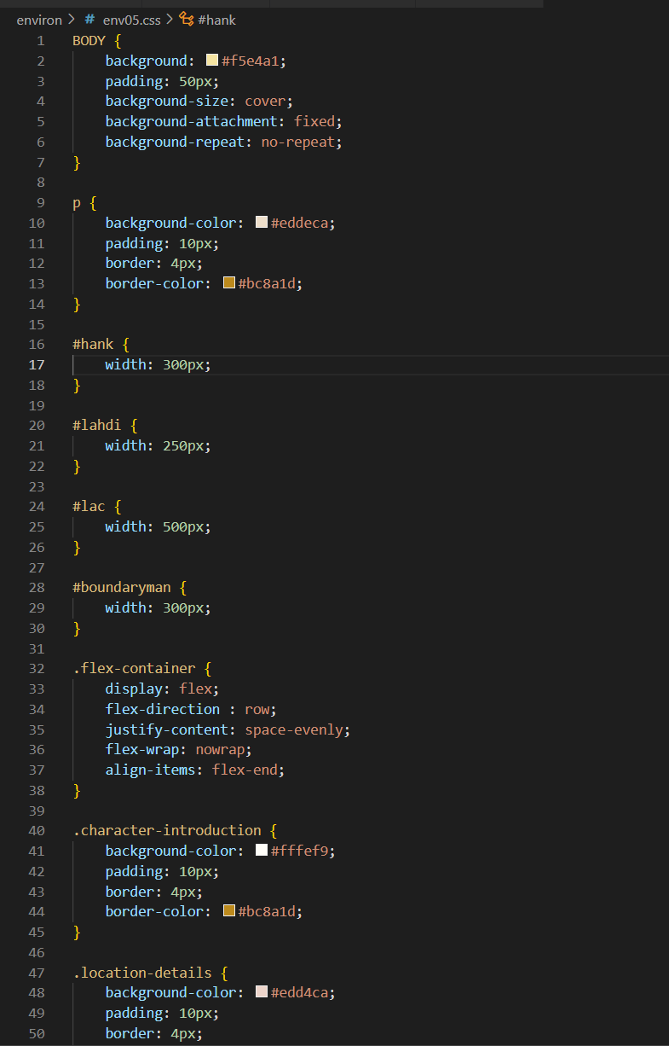
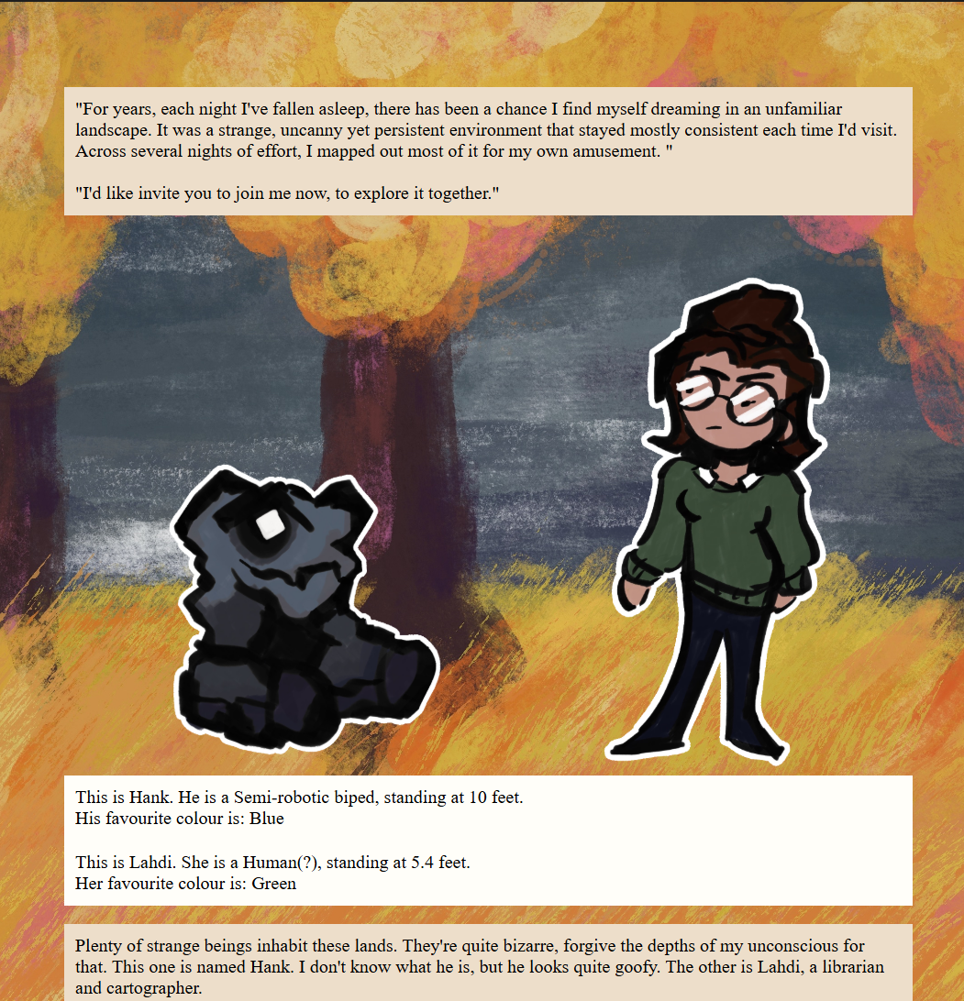
It’s difficult to demonstrate the changes here. You need to click on the figures, and they’ll jump a bit.

Task 3

https://natashamakani.github.io/ART101New/

Task 4
- I had no challenges with Task 1! The most strenuous part was writing the paragraphs and finding something to fill them with.
- For task 2, I wanted to make my little characters do a jump when you clicked on them. I also wanted them to be transparent when you hovered over them, so you can see more of the background behind. For a while, I struggled to get them to work because the ‘left’ or similar attributes wouldn’t do anything despite registering clicks, so I instead opted to adjust their height.
- Luna and I sent screenshots and thoughts to one another throughout our process, and she helped me get past a little snag early on.

